Invitation to Tender – ESA Polar Science Cluster
Title: Indigenous Community Engagement - ROADS
Proponent: Sustaining Arctic Observing Networks, Arctic Monitoring and Assessment Programme, Arctic Council
Objective: The proposal has a two-fold objective both of which will engage with, and develop capacity within, the Indigenous northern communities in a meaningful manner that brings their knowledge and expertise into the co-design of the Roadmap for Arctic Observing and Data Systems (ROADS) approach.
- The first objective is to establish and implement the Sustaining Arctic Observing Networks (SAON) ROADS Advisory Panel through co-design and close collaboration with local and Indigenous communities, and Indigenous organizations.
- The second objective is to build interdisciplinary teams and networking efforts that will bring together Indigenous collaborators, with regional science networks and global observing networks, to explore how Indigenous Knowledge and community based monitoring can be brought together to address the societal challenges facing the Arctic. This approach will bring value-added to earth observation activities, including those of the European Space Agency, by assisting in the development of co-designed advisory and engagement strategies in order to derive highest shared value from ESA investments in the Arctic region.
Executive Summary:
The SAON ROADS approach clearly states that “a critical success factor for ROADS is the equitable inclusion of Arctic Indigenous Peoples in the design and development process, using the design of process to build needed equity.” This close collaborative relationship in creating and implementing the ROADS Advisory Panel, as the key oversight body of the ROADS process, will be the fundamental underpinning of the ESA ITT proposal. In addition, the proposal will explore how Indigenous communities and their knowledge can be brought to the decision making process through Indigenous Community Engagement. The proposal will prepare-the-ground for how this Indigenous knowledge can be brought to bear on the societal challenges that are facing the Arctic by examining several case studies. This proposal will focus on and advance the human-side of the ROADS process.

Background/Context:
Overview of SAON ROADS Process: SAON is uniquely positioned to work on Arctic observing networks as it represents the pan-Arctic both in its membership and its mandate. SAON set forth a bold vision in its 2018-2028 Strategic Plan to develop a Roadmap for Arctic Observing and Data Systems (ROADS). This Strategic Plan marks a transition in SAON’s focus from community-building and partnership development towards a more active role in planning for the systematic design and implementation of the Arctic observing system.
The lack of consistent and holistic planning mechanisms to assess observing system priorities and link independently funded efforts across the Arctic can be viewed as a persistent short-coming that has hindered adaptation strategies and hampered funding responses for an improved observing system. ROADS seeks to address this shortcoming through generating a systems-level view of observing requirements and implementation strategies, across SAON’s many partners, through its Roadmap. A critical success factor for ROADS is the equitable inclusion of Arctic Indigenous Peoples in the design and development process, using the design of process to build needed equity. ROADS is both aspiring towards a holistic concept, building from the societal benefit-based approaches of the International Arctic Observing Assessment Framework and those informed by Indigenous world view like the Inuit Circumpolar Council Food Security Framework and the Saami Council’s Arctic Strategy. The combination is one that can proceed step-wise so that the most imperative Arctic observations – Shared Arctic Variables (SAVs) – can be rapidly improved.
Finally, it must be re-stated and underscored that within the SAON and the ROADS processes that Arctic Indigenous Peoples need to be recognized as rights holders and knowledge holders in the Arctic, and research in their homeland must be conducted in partnership with them. Governance of and progress under ROADS shall be shaped by and will benefit greatly from this critical consideration.
Shared Arctic Variables - the Foundation of Arctic Observing Networks: The SAV concept (Fig. 1), while inspired by and inclusive of the “essential variable” approaches of the global (e.g. Global Ocean Observing System) networks, has differentiating considerations that support equitable decision making in their identification, design, and development process. SAVs, like essential variables in general, share the concept of subdividing the system of interest - in this case the Arctic System - into manageable units for planning and collaborative development that are based around characterizing phenomena of the system - like Sea Ice.
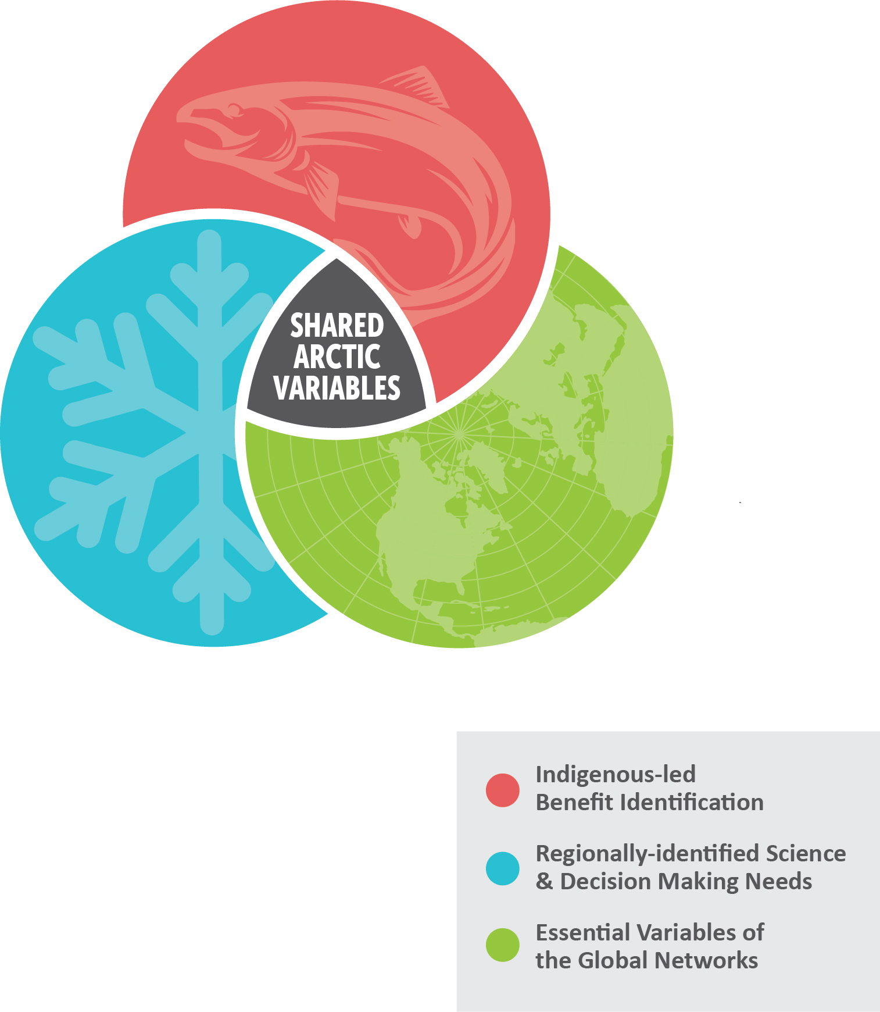
Figure 1: Shared Arctic Variables
The ROADS process supports a view that taking the Arctic System as a whole is vital in determining how it should be most relevantly characterized, in balance with recognizing it as part of diverse global systems like the global atmosphere, oceans, and biosphere. It is also relevant to think about characterizing the system through a related set of essential processes, as the highly interconnected Arctic System cannot be understood from the standpoint of the state of any single given variable. With these considerations in mind, the SAON’s Roadmapping Task Force (RMTF) concluded that an essential variable/process approach is a robust one. In the context of ROADS, such as approach can support the guiding principles of building off of existing planning efforts, which already use essential variables, and proceeding step-wise.
Unlike other essential variable frameworks, SAVs must address a diversity of societal benefits that cross scales from local to regional to global and they must entrain a diversity of perspectives, knowledge systems, and approaches in their implementation. For example, SAON expects that the equitable inclusion of Indigenous Knowledge and world-view will redefine and expand upon our conceptualization of Arctic-relevant phenomena (e.g. sea ice, permafrost, or snow) that have largely been characterized from a scientific worldview. For both of these reasons, SAVs under the ROADS process will be differentiated from and improve upon essential variable concepts.
Observations and data systems that warrant the level of effort associated with the ROADS process should serve multiple sectors and data user groups, and ideally address priorities at the intersection of Arctic community-identified needs, regionally identified cross-sectoral needs and those of the global observing programs. For example, an SAV might address information needs expressed by Arctic coastal communities from a coastal hazards perspective, serve Arctic research interests focused on long-term trends and variability in the state of the coastal seas, and preferably also tie back to one or more Essential Climate Variable in the context of GCOS. In contrast, observations of an essential variable that has been prioritized by a global observing program and is tracked by a single group of constituents is not contingent on high-level, cross-sector, international coordination.
Co-Design of Shared Arctic Variables: Critical to the ROADS and the Shared Arctic Variables approach is that SAVs shall be co-designed from the on-set. Co-design requires the need for equity in decision making and equity in bringing knowledge to the decision-making process. This implies a need for funding for Indigenous subject matter experts. Co-design also implies community networking efforts amongst local and Indigenous communities engaging with regional, national, and international scientists.
The ROADS process, including the identification of the SAVs, is in its formative stages where the full engagement, networking, and design of Indigenous partners will be very impactful. The need to co-design requires that all parties have the capacity to engage, discuss, and recommend variables. Time and capacity development is required amongst Indigenous partners to be able to fully participate. While these efforts may be initiated immediately, the transition to full participation, engagement, and discussion will need to take place over several months due to the exigencies of co-design. It is very important that initiatives are undertaken “with the communities” and not “for the communities”; in some cases, community-led activities are most appropriate.
This proposal, therefore, outlines specific investments in co-design partnerships that acknowledge specific financial hurdles that often prohibit legitimate engagement with Indigenous communities and organizations. It responds to a specific critique of Arctic planning processes voiced by Indigenous communities, namely that they are too often asked to volunteer their time towards processes without equitable compensation. Related deliverables are identified that will explore how Indigenous knowledge can be brought to the decision making process, which will ultimately benefit the objectives of conventional, globally-oriented observing systems, like those supported by ESA, and their value added data products.

For example, under the EU Horizon 2020 project INTAROS, a key deliverable concerned the identification of observing system gaps and their implications through the global/scientific lens of ESA/Copernicus. Revisiting this Gaps Analysis in partnership with Indigenous Knowledge holders and the lens of community-based needs would strengthen the conception of these gaps, bring focus through understanding community priorities and identify specific means through which Indigenous communities can enhance the observing networks, particularly through human observations. This approach will bring value-added to earth observation activities, including those of the European Space Agency, by assisting in the development of co-designed advisory and engagement strategies to link this analysis with the Indigenous-led benefit identification (red circle in Fig. 1) and Regionally-identified science and decision making needs (blue circle in Fig. 1) in order to derive highest shared value from ESA investments in the Arctic region. The broader impacts of these outcomes will support a robust establishment of the ROADS process that will enable SAON to scale up its partnerships into an active network of co-design activities in Arctic observing.
The overall governance and approval of SAV deliverables under ROADS should be a collaborative process that draws from core SAON communities: national governments, Indigenous Peoples, local communities, operational observing entities, and scientists (organized in many research networks). The concept for this collaborative co-design process is to invite Expert Panels (EPs), that regionally-centered and/or thematically-driven, to identify the most critical SAVs and to work toward developing their requirements for observing and data systems, and ultimately integrated implemented strategies which will include remotely-sensed and in situ observations as well as community-driven human observations.
EPs may convene around either a region or a subject of relevance; their scope should be broad enough to cover at least one SAV, but preferably a related set of SAVs. Participation in the panels must be as inclusive and relevant as the scope of intended societal benefit itself, drawing subject matter experts from academia, Indigenous organizations, northern communities, operational agencies, partner organizations, industry, and government.
Indigenous Community-led Observing Initiatives:
Indigenous community-led observing initiatives have been developing around the Arctic as a means of using Indigenous Knowledge to support the observations that communities need for specific societal benefits (e.g. food security, ice safety, etc.). These initiatives have already had societal impacts on local communities and have had direct involvement of local communities as part of their science process. The ROADS process is learning from the extensive and different approaches of these Indigenous community-led initiatives and how different they are from the western approaches to Arctic observing and networks. For example, the Indigenous community work involves more dialogue and conversations to ascertain how Indigenous Knowledge can be used to support the observations that are needed to identify and develop Shared Arctic Variables. Considerable effort must be expended to prepare the ground so as to successfully bridge between Indigenous Knowledge and western science in the development and implementation of Shared Arctic Variables and to inform specific approaches on how to proceed.

The Advisory Panel – High Level Support and Guidance of ROADS:
The ROADS Advisory Panel, established under SAON, is intended to provide a neutral and collaborative standing body that provides oversight to the ROADS Expert Panels. In order to avoid issues of “siloing” and to support equity in the ROADS process, the AP will facilitate alignment between and across EPs at each phase of their progress. The AP will also assure that each Shared Arctic Variable is identified, defined and follows an implementation strategy that is consistent with ROADS principles.
Fig. 2 depicts a future-oriented vision of the ROADS Integrated Advisory Process. This vision foresees a strong ROADS Advisory Panel that will facilitate integration (the vertical strands) that will weave together across diverse Expert panels (the horizontal strands) as they incrementally progress through the SAV process.

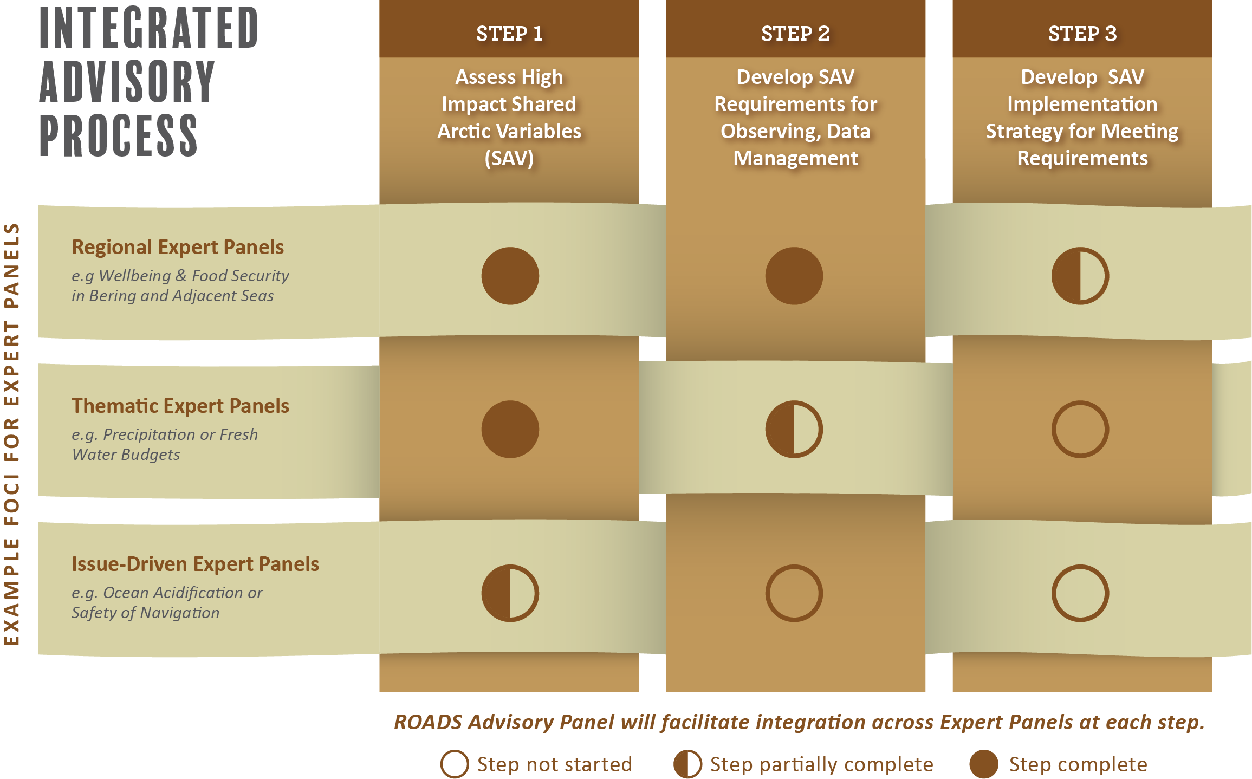
Figure 2: ROADS Expert Panels in an Integrated Advisory Process – illustrating that a strong advisory process (the vertical strands) is needed to weave together across diverse Expert panels (the horizontal strands) as they incrementally progress through the process
In addition to assuring an integrated and inclusive process, the AP will have the mandate to foster integration with other panels; mobilize international participation and collaboration with global networks; and work to cultivate consensus approaches across panels. The ROADS AP should also work with relevant funding agencies and organizations to advance support for EP efforts, including their implementation strategies. In regards to membership and representation on the Advisory Panel, it is envisioned that representatives will come from SAON’s Board, SAON Committees, and partners. Given the principles for ROADS, Indigenous participation in the development and implementation of the AP is essential.
One of the first steps undertaken by the SAON Board to initiate the ROADS process was the creation of the Road Map Task Force (RMTF). The RMTF was tasked to set forth definitions and guidelines for the community in order to mobilize expertise towards the strategic expansion of the Arctic Observing System. These recommendations were critiqued and enhanced through a partnership with the 2020 Arctic Observing Summit (AOS), where each of its five AOS working groups reviewed the initial recommendations for ROADS and deliberated improvements.
Building on this earlier work of the RMTF and the 2020 AOS, the RMTF held a workshop to discuss the mandate and composition of the ROADS Advisory Panel. At the workshop, it was clear that Indigenous engagement in the AP is a challenge. It was first noted that there are a range of ways in which Indigenous Peoples self-organize, from Permanent Participants in the Arctic Council, to regional non-profits, to tribal units and more. Further, Indigenous and non-Indigenous scholars work on ROADS-relevant issues, including frameworks for the co-production of knowledge. Giving voice to the diversity of these perspectives, particularly on a representation-driven body like the ROADS AP presents a challenge. One recommendation was to draw from existing Indigenous governance structures in developing the quality of Indigenous viewpoints in ROADS. The workshop discussions also noted the diversity of Indigenous communities stating that broad and equally diverse participation needs to be achieved in SAON ROADS committees and panels (e.g. one Indigenous representative is not sufficient). Furthermore, it was noted that compensation for Indigenous expertise is a necessary consideration.

Work Plan – General
SAON is uniquely positioned to work on Arctic observing networks as it represents the pan-Arctic both in its membership and its mandate. Under SAON’s leadership, the ROADS Advisory Panel will be established and implemented in a manner that sees co-design and close collaboration with local and Indigenous communities, and Indigenous organizations. This approach will evolve methodically given the time and effort to build up capacity amongst all partners. The same need to build up capacity in partners involved in the Expert Panels will be necessary in the interdisciplinary team development that will see Indigenous communities actively engaging in the co-development of Shared Arctic Variables.
In addition, under the ROADS Advisory Panel, interdisciplinary teams and networking efforts will be enabled that will bring together Indigenous collaborators, with regional science networks and global observing networks, to explore how Indigenous Knowledge and community based monitoring can be brought together to address the societal challenges facing the Arctic. This will bring considerable value-added to earth observation activities, including those of the European Space Agency, by assisting in the development of co-designed advisory and engagement strategies to link this analysis with the Indigenous-led benefit identification and Regionally-identified science and decision making needs in order to derive highest shared value from ESA investments in the Arctic region. The broader impacts of these outcomes will support a robust establishment of the ROADS process that will enable SAON to scale up its partnerships into an active network of co-design activities in Arctic observing.
During this time of the global pandemic, the necessity of longer time considerations must be underscored. It is more challenging and time consuming during the ongoing pandemic to find new partners, to arrange and participate in virtual meetings which often have their own elevated costs for Northern residents, to develop personal relations via on-line discussions, and to move successfully forwards in program development and delivery.

Work Plan Activities (that have associated funding needs)
Establishment of ROADS Advisory Panel by the SAON Board
- Identify and appoint Local and Indigenous community representatives as members of the Advisory Panel. This will necessitate appropriate financial compensation to representatives for travel, engagement and capacity building. The ROADS Advisory Panel will be an inter-sectoral team, with broad representation from not only Local and Indigenous communities, but also from across pan-Arctic sectors including citizens, communities, governments, industry.
- The proposed Indigenous Community Engagement expertise (see below) could also assist in the establishment of the Advisory Panel, by helping SAON to better understand the Indigenous governance landscape diversity in order to make the most inclusive choices regarding the Advisory Panel membership.
- One of the first tasks for the ROADS Advisory Panel will be to co-design governance aspects of the Panel including: the workplan, terms of reference, mandate, deliverables and milestones.

Operations of the ROADS Advisory Panel

- Oversight of the Expert Panels – The AP will provide guidance and advice to the newly created Expert Panels; encourage Indigenous community networking efforts in the development of ROADS Expert Panels; interact with the ROADS Expert Panels following a multi-phase process as described in the SAON ROADS paper; and, determine if or where are gaps amongst the Expert Panels.

- Development of Engagement Matrix and Strategy – The AP will oversee the development of an Engagement Strategy (e.g. who, what, why, when) with Indigenous partners and efforts on ROADS process. The Engagement Strategy should outline the many organizations across the scales and how they might fit into the holistic Expert Panel and Advisory Panel landscape. It should also include specific recommendations for how Indigenous experts should be compensated under the ROADS process.
As a building step in this engagement process, a Horizontal Scan will be conducted to provide a deeper understanding of co-design and collaboration with northern Indigenous communities. This will provide lessons to learn from, best practices and perhaps approaches to be avoided. The intent of the proposal is to build successful interdisciplinary teams that can be reflective of other lessons to date.
Another component of the study would be a Review of Sponsor Organization Projects (e.g. ESA Polar, Copernicus, and EU Arctic Cluster Projects) to seek the most opportune manner to capture their ability to contribute to ROADS approach, identify possible approaches to strengthen their work by facilitating insight from the Indigenous Community Experts and reflect this in the co-designed Engagement Strategy.
- Conduct a Comparative Analysis Study – The AP will conduct a comparative analysis study to examine the approaches of western science earth observation initiatives versus the approaches of Indigenous community based observing initiatives. The Analysis could explore the philosophical approaches and work of each, identify opportunities for co-design and knowledge sharing between the approaches and seek means of blending lessons-learned and best practices.
One aspect of this study would be a Dialogue with Copernicus In Situ Coordination Group that would look at their overall efforts and in particular their work on the gaps analysis in Arctic observations, including the Copernicus Arctic Data Report (https://insitu.copernicus.eu/library/reports/CopernicusArcticDataReportFinalVersion2.1.pdf). The AP could dialogue with the Copernicus efforts in a discussion and advisory capacity to consider requirements for Arctic observation variables – examining the co-design and knowledge sharing from the AP Indigenous Community Experts.
- Update the Atlas of Community Based Monitoring - The Atlas shows the capabilities and competencies of Indigenous Community Based Monitoring and represents an evergreen document and resource for the community. The Atlas will be updated to current efforts so as to demonstrate the proposal bona fides and to indicate the potential breadth of the scope of impacts of the ROADS process.

Creation of Indigenous Community Engagement Experts
- Indigenous Community Engagement experts will be identified to provide advice and guidance on the development of Indigenous knowledge to support the observations needs for specific societal benefits (e.g. food security, ice safety, etc.). Several Indigenous community-monitoring initiatives are already in place and these initiatives have already had impacts on local communities and have had direct involvement of local communities as part of their science process. Efforts will build interdisciplinary teams and networking efforts that will bring together Indigenous collaborators, with regional science networks and global observing networks, to develop Shared Arctic Variables as the foundation of the ROADS process. These Indigenous Community Engagement Experts could also assist in the establishment of the Advisory Panel, by helping SAON to better understand the Indigenous governance landscape diversity in order to make the most inclusive choices regarding the Advisory Panel membership.
- The following Indigenous Community-led Initiatives are to be considered as potential Indigenous Community Experts to provide guidance to the ROADS Advisory Panel

- SIKU, The Indigenous Knowledge Social Network – This Indigenous network facilitates self-determination in research, education and stewardship for Indigenous communities. Efforts under this initiative have led the development of a mobile app and web platform by and for Inuit which provides tools and services for ice safety, language preservation and weather. Work is based on the guiding principles of respect, self-determination, intellectual property and integrity. Use of satellite data (e.g. Sentinel-2) is accessed and compared with in-situ observations of Inuit community members.
Contact: Joel Heath joelheath@gmail.com
Reference: https://siku.org

- ISAAFFLIK - Isaaffik is the Greenlandic word for gateway. The ISAAFFIK Arctic Gateway is a user driven web platform supporting research and collaboration. This Gateway creates a platform for collaboration, inspiration, synergies and creativity for research, education, consultancy and logistics. ISAAFFIK is an independent and public forum that is open to anyone engaged in Arctic research, education, consultancy, infrastructure, and logistics. The content of the website is maintained by a number of ISAAFFIK partners and contributors.
Contact:
Reference: https://www.isaaffik.org/

- Food Security Working Group (Working Group: Observing in Support of Indigenous Food Security and Related Needs, Sub-Theme 3 of the Arctic Observing Summit) - This Working Group has been examining approaches and priorities to increase the efficiency, reach and impact of observations in support of Indigenous food security and related needs. Since the 2020 Arctic Observing Summit, the Working Group has worked towards the formulation of actionable recommendations and charting a path for observing activities related to an increased understanding of Indigenous food security.
Contact:
Raychelle Daniel rdaniel@pewtrusts.org
Gunn-Britt Retter gbr@saamicouncil.net
Reference:

- Snowchange - The Snowchange Cooperative is a network of local and Indigenous cultures around the world – partners include the Saami, Chukchi, Yukaghir, Inuit, Inuvialuit, Inupiaq, Gwitchin, Icelandic, Tahltan, Maori, Indigenous Australian and many other local and Indigenous peoples and communities. The Cooperative is a powerful scientific organisation that works with the Arctic Council, Intergovernmental Panel on Climate Change, Indigenous Peoples Climate Change Assessment, National Science Foundation of USA, several universities and partners on questions of biodiversity, climate change and local communities. Snowchange represents the positive change the North needs with Indigenous communities leading efforts at local, regional, national and global discussions.
Contact:
Reference: http://www.snowchange.org/

- Drivers and Feedbacks of Changes in Arctic Terrestrial Biodiversity (CHARTER) – CHARTER is an ambitious effort to advance the adaptive capacity of Arctic communities to climatic and biodiversity changes through state-of-the-art synthesis based on thorough data collection, analysis and modelling of Arctic change with major socio-economic implications and feedbacks. To achieve this goal, CHARTER will combine expertise from Earth System sciences and biodiversity studies within a social-ecological system (SES) framework and with a strong participatory approach. Strategies co-developed in CHARTER with Indigenous and local communities will comprise synergies between their ambitions for adaptation actions with novel forms of land management geared towards climate change mitigation and sustainable development.
Contact: Annett Bartsch annett.bartsch@bgeos.com
Reference: http://www.charter-arctic.org/

- Inuit Circumpolar Council (ICC) – The ICC is the body that represents all Inuit from Alaska, Canada, Greenland, and Chukotka on matters of international importance. The ICC has been a very active partner in SAON and the ROADS process with the ability to reach within their member countries for further engagement. The ICC developed the first Community-based Monitoring Atlas as a basis to showcase Indigenous observing networks.

Contact: Eva Krummel ekruemmel@scientissime.com
Reference: https://www.inuitcircumpolar.com/

ROADS Cyber Infrastructure
- The Advisory Panel will need to acquire or build cyber infrastructure so as to enable the Panel to have the right tools available to implement the ROADS process. This infrastructure needs to be would be more than a document-manager and provide a live and interactive mechanism that would enable exploration of Value Tree or for multiple criteria decision analysis with the value tree work as a subset.

Advisory Panel Administration:
- Administrative support will be required to manage the Advisory Panel process and support the deliverables

Deliverables:
Year 1 (April 2021 – March 2022; Months 1 -12)
Month | Deliverable
1-4 | Identification and selection of five Indigenous Community Engagement Experts - who will assist SAON to better understand the Indigenous governance landscape diversity in order to make the most inclusive choices regarding the AP membership; and who will be actively engaged in co-design and co-development of the ROADS Advisory Panel and its activities
1-4 | Identification and selection of additional members to the Advisory Panel from regional and global observing networks and science organizations – with advice from the Indigenous Community Engagement Experts and SAON Board
Milestone  Month 4 | ROAD Advisory Panel membership is approved by the SAON Board
5-6 | Meeting of Advisory Panel- discussions will focus on the co-design the following components of governance of the AP including:  - Terms of Reference  - Mandate  - Consideration of requirements for AP operation, including cyberinfrastructure needs (sub-committee to be formed to develop technical requirements and table recommendations to the AP)  - Annual workplan, including deliverables and milestones
5-6 | Expert Panels will be formed and will have initiated work on Shared Arctic Variables
5-6 | Conduct a Horizontal Scan to provide a deeper understanding of co-design and collaboration with northern Indigenous communities; capture lessons learned and successes from others. The Horizontal Scan will be key to the development of the Engagement Matrix and Strategy.
6-8 | Develop an Engagement Matrix and Strategy that outlines the many organizations across the scales (community, regional, national, global) and how they might fit into the holistic Expert Panel and Advisory Panel landscape. The Strategy will examine the “who, what, why, when” with Indigenous partners and efforts on ROADS process.
6-8 | Another component of the study would be a Review of Sponsor Organization Projects (e.g. ESA Polar, Copernicus and EU Arctic Cluster Projects) to seek the most opportune manner to capture their ability to contribute to ROADS approach, identify possible approaches to strengthen their work by facilitating insight from the Indigenous Community Experts and reflect this in the co-designed Engagement Strategy
8 | Meeting of Advisory Panel will be held; discussions will:  - Provide oversight guidance and advice to the newly formed ROADS Expert Panels following the multi-phase process as described in the SAON ROADS process  - Confirm requirements for AP operation, including cyberinfrastructure needs so that options may be developed on technical requirements and operation  - Review, discuss and approve the Horizontal Scan and Engagement Matrix and Strategy that will be in draft form  - Consider requirements of the Comparative Analysis Study that will be undertaken in coming months
9-12 | In association with the Engagement Matrix and Strategy, conduct a Review of Sponsor Organization Projects (e.g. ESA Polar, Copernicus and EU Arctic Cluster Projects) to seek the most opportune manner to capture their ability to contribute to ROADS approach, identify possible approaches to strengthen their work by facilitating insight from the Indigenous Community Experts and reflect this in the co-designed Engagement Strategy
9-12 | Conduct a Comparative Analysis Study to examine the approaches of western science earth observation initiatives versus the approaches of Indigenous community based observing initiatives. The Analysis could explore the philosophical approaches and work of the two, identify opportunities for co-design and knowledge sharing between the approaches and seek means of blending lessons-learned and best practices.
9-12 | Initiate and formalize a Dialogue with Copernicus In Situ Coordination Group that would look at their overall efforts and in particular their work on the gaps analysis in Arctic observations, including the Copernicus Arctic Data Report (https://insitu.copernicus.eu/library/reports/CopernicusArcticDataReportFinalVersion2.1.pdf). The AP could dialogue with the Copernicus efforts in a discussion and advisory capacity to consider requirements for Arctic observation variables – examining the co-design and knowledge sharing from the AP Indigenous Community Experts.
11-12 | Meeting of Advisory Panel will be held; discussions will:  - Provide guidance and advice to the ROADS Expert Panels following the multi-phase process as described in the SAON ROADS process  - Discuss and approve requirements for AP operation, including cyberinfrastructure needs will be presented and recommendations prepared on technical requirements and options for implementation
Milestones  By 2022 AOS | - Completed assessment of 2 to 4 Societal Benefit Areas and their underlying objectives  - Development of 2-4 Shared Arctic Variables through at least Phase II of the ROADS process, ideally at least one SAV will have gone through all 3 Phases of development  - Defined requirements for cyberinfrastructure in support of ROADS.

Year 2 (April 2022 – March 2023; Months 13-24)
Month | Deliverable
1-4 | Update the Atlas of Community Based Monitoring - The Atlas shows the capabilities and competencies of Indigenous Community Based Monitoring and represents an evergreen document and resource for the community. The Atlas will be updated to current efforts so as to demonstrate the proposal bona fides and to indicate the potential breadth of the scope of impacts of the ROADS process.
4-5 | Meeting of Advisory Panel will be held; discussions will:  - Provide guidance and advice to the ROADS Expert Panels continuing to follow the multi-phase process as described in the SAON ROADS process  - Assess and determine if or where there may be gaps amongst the Expert Panels  - Approve cyber infrastructure requirements and approach; approve moving to implementation
8 -9 | Sixth Meeting of Advisory Panel will be held; discussions will
12 | Seventh Meeting of Advisory Panel will be held; discussions will  - Cyber database infrastructure will have been developed and implemented
By 2024 AOS | - Completed assessment of 5 to 8 Societal Benefit Areas and their underlying objectives;  - Development of further Shared Arctic Variables, as relevant, through all 3 Phases of development;  - Development of cyberinfrastructure to support ROADS.

FUNDING (150,000 Euros each of 2 years)
Types of funding
Salary for AMAP administration of AP and numerous studies
Operating funds to Indigenous Community Engagement Experts for compensation of time and effort to engage in AP activities
Operating funds for travel to AP meetings, hosting AP meetings, travel to partner organizations
Capital funds for acquisition and operation of Cyberinfrastructure needs

Proposal Activities:
Creation of Indigenous Community Engagement (ICE) Experts
Establishment of ROADS Advisory Panel by the SAON Board
- Funds required for ICE experts to enable their participation/advice in identification of additional members to the AP
Operations of the ROADS Advisory Panel
Funds will be required for:
- ICE Experts to contribute to the operations of the ROADS Advisory Panel in a broad sense (e.g. time commitments in participating in and reviewing the numerous studies that the AP will produce)
- Travel expenses for face-to-face meetings after the pandemic
- Oversight of the Expert Panels –Funds required for ICE experts to build capacity; review documents; provide advice
- Development of Engagement Matrix and Strategy – conducted by ROADS AP Administration
  - Horizontal Scan - conducted by ROADS AP Administration
  - Review of Sponsor Organization Projects - conducted by ROADS AP Administration
- Conduct a Comparative Analysis Study – conducted by ROADS AP Administration
  - Dialogue with Copernicus In Situ Coordination Group - conducted by ROADS AP Administration
- Update the Atlas of Community Based Monitoring - conducted by ROADS AP Administration
ROADS Cyber Infrastructure – capital funds to acquire; operating funds thereafter
Advisory Panel Administration - Salary for administration needs relating to the proposal

Sustaining Arctic Observing Networks’ (SAON) Roadmap for Arctic Observing and Data Systems (ROADS); S. Starkweather et al; Arctic, 2022, in preparation
Nikoosh Carlo, AOS WG Food Security, White Paper from Arctic Observing Summit 2020
Arctic In-situ Data Availability, 09/12/2019, E. Buch et al, Framework Service Contract EEA/IDM/15/026/LOT 1 for Services supporting the European Environment Agency’s (EEA) implementation of cross-cutting activities for coordination of the in situ component of the Copernicus Programme Services
I couldn’t find these…..need a reference or url please

