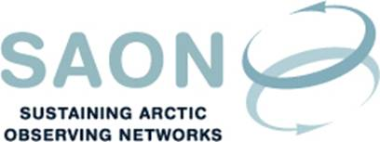

Meeting of Committee on Observations and Networks (CON)

20 April 2017 17-18 CET / 11-12 AM EST
Telephone conference
Draft agenda

Welcome to the call

SAON Board meeting 7th April

INTAROS

Draft Work Plan – Review

Any other business

